**SUMMARY**

This is a meme website featuring a fictional and licensed character with a single goal: to have fun.

The art of the website should strictly be in a MS Paint style and inspired by the internet culture.

The character should be interacting with elements across the website page, and the website should feel playful and fun to navigate.

**BRAND COLORS**

|  |  |  |  |
| --- | --- | --- | --- |
| **Tones** | **Color Code** | **How to use it** | **Example** |
| Clear Green | #48E2A4 | Main colors of elements such as button, it is combined with the other 2 greens |  |
| Mid-Dark Green | #148A72 | Use for shades of Clear Green. |
| Dark Green | #1B453B | Outlines. |
| White | #FFFFFF | Background, highlights, lines/bands on the greens |

The background should be white and sometimes may have touches of greens.

The menu buttons should use the Clear Green, Mid-Dark Green, Dark Green, and White (similar to the pill above).

MS Paint could inspire some of the aesthetic elements, such as those at the bottom of the illustration tables (And other if any fit)

**FONTS**

Titles: Luckiest Guy

General Text: VCR OSD Mono

**MENU**

**ABOUT – CHART – FOLLOW ON X**

**ABOUT PAGE CONTENT**

|  |  |
| --- | --- |
|  | Just below the illustration above, include something as follow  FUN  Of THE PUMP  “PUMP” can be replaced by the pill with PUMP written on it, as follows: A green and white pill  AI-generated content may be incorrect.  PU MP |

**WELCOME TO THE PUMPFUNVERSE**

My name is FUN, the guy of the pump!

**PUMPFUNVERSE** is a large amusement park with candle jumping, swingers and jeets popping activities.

Join me now at this fun playground where we can mess around, such as using the announcement system to call out Alon, slurping some green and red lollipops with unstable degens, or hanging out at the DEXSCREENER arena for PvP plays.

Born on **MS** **Paint**, raised on **PUMPFUN**,   
I’m the FUN of the PUMP

GRAB YOUR TICKET TODAY!

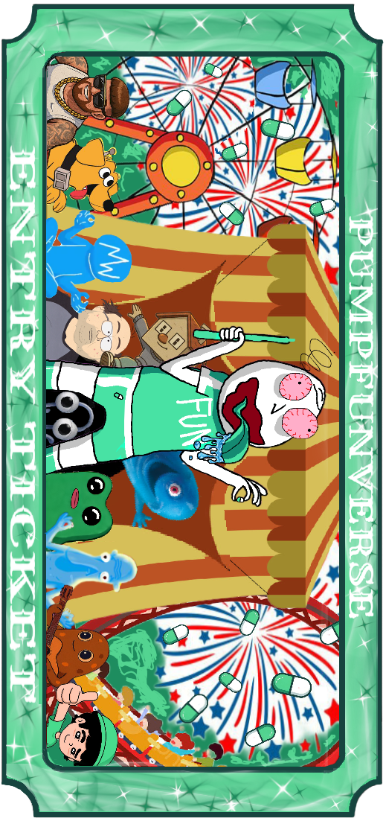

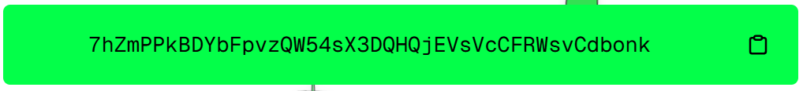

Add a DEXSCREENER LOGO and an X logo as on the reference website

Then, add the following disclaimer at the bottom of every page:

Disclaimer: This is just a meme coin, not financial advice—do your own research, apes only at your own risk and for the lols.

I will share the Chart link and the X link once we are ready to launch.

**ILLUSTRATIONS**

|  |  |
| --- | --- |
|  | Logo (instead of Untitled at the top, can you have: FUN.jpg - written similarly as the rest of the text, please?)  Please incorporate it nicely. |
|  | This illustration could be somewhere at the top |
|  | This illustration could be used as the character hanging from a menu button or one element of the website |
|  | This illustration could be used as an element that flies across the website as users scroll down, from right to left (Similar animations as the background candles of that website: <https://www.buckybonk.io/)> |
|  | This illustration could be used as an element that flies across the website as users scroll down, from left to right – without crashing into the animation above. (Similar animations as the background candles of that website: <https://www.buckybonk.io/)> |
|  | This illustration could be used as an element that flies across the website as users scroll down, diagonally from right to left – without crashing into the animations above (Similar animations as the background candles of that website: <https://www.buckybonk.io/)> |
|  | This illustration could be placed near critical information, such as the description or the coin chart (the chart may need to be added later). |
|  | This illustration could be added near some of the information. |
|  | This illustration could be used as the character hanging from a menu button or one element of the website. |
|  | This illustration could be added at the bottom. |
|  | Can we use it instead of the regular cursor, please. |
|  | Can add this somewhere to add to the theme too |